

NOVAC TECHNOLOGY SOLUTIONS

User Manual

Document Version No.: 1.00

Revision History
Version No | Reason For Changes | Author | Approver
0.01 | Draft | Anurag Kumar
1.00 | Reviewed & Approved the User Manual | Anurag Kumar | NIJANTHAN PL

Table of Contents
1. Introduction 4

2. Required to display only Intermediary code 4

Introduction

As per the requirement, Intermediary code should display in the Policy schedule SOA document for all lob products.
- Guidelines, circulars, instructions and directions released from time to time by Philippines Insurance council.

Required to display only Intermediary code

- System should display the Intermediary information in the policy schedule when generating the policy schedule document.
- System should display the Intermediary details as “Intermediary Code” in the schedule document for the respective policy.
- Intermediary code will display in the policy schedule for all lob products.
Kindly Generate the Policy Schedule from Policy Schedule screen or while generating the policy.
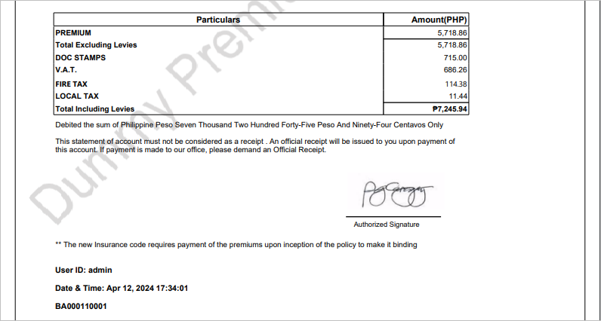

Click on close button to close the window.

